COMPLETE BLOOD GAS ANALYSER
Blood gas analyzers are designed to measure pH, pCO2 and pO2 from a single sample of whole blood. The size of the sample may vary from 25 μl to a few hundred microlitres. The estimations take about 1 minute. With built-in calculators, the instruments can also compute total CO2, HCO3 and Base Excess. A typical block diagram of a blood gas analyzer machine is shown in Figure below.

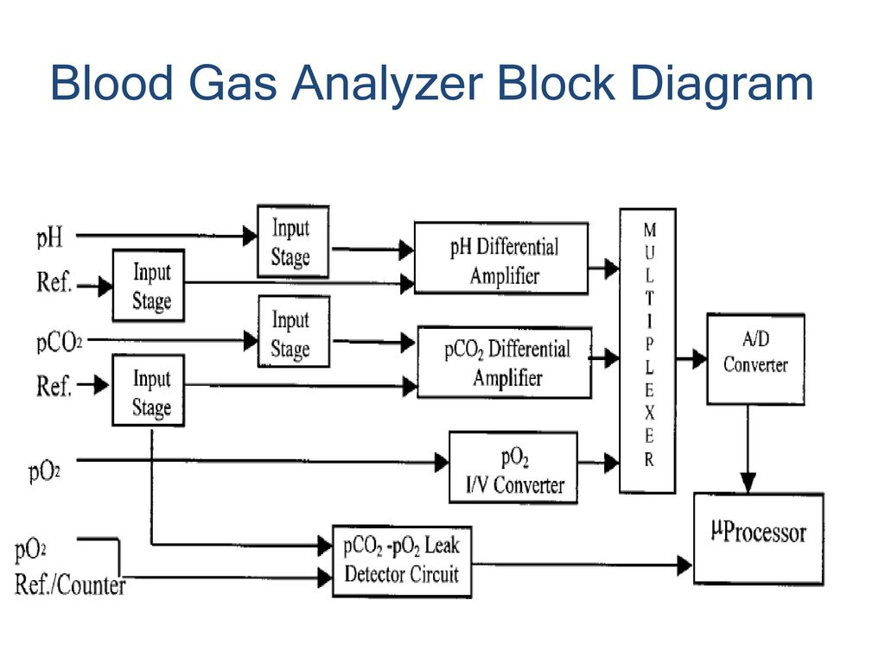

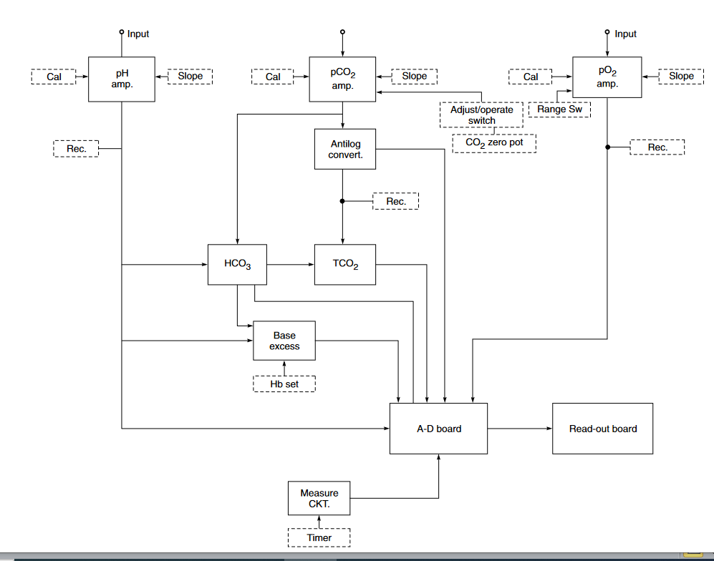
In this machine, separate sensors are used for pH, pCO2 and pO2. The instrument contains three separate high input impedance amplifiers designed to operate in the specific range of each measuring electrode. A separate module houses and thermostatically controls the three electrodes. It also provides thermostatic control for the humidification of the calibrating gases. A vacuum system provides aspiration and flushing service for all three electrodes. Calibrating gases are selected by a special push button control and passed through the sample chamber when required. Two gases of accurately known O2 and CO2 percentages are required for calibrating the analyzer in the pO2 and pCO2 modes. The gases required are: O2 value of 12% Cal and 0% Slope and CO2 value of 5% Cal and 10% Slope. These gases are used with precision regulators for flow and press-ure control. Two standard buffers of known pH are required for calibration of the analyzer in the pH mode. The buffers that are used are 6.838 (Cal) and 7.382 (Slope). It is generally recommended that the sample chamber should control 7.382 buffer when in the standby mode.

Input signal to the (HCO3–) calculator (Fig.2.3 below) comes from the outputs of the pH and pCO2 amplifiers. The outputs are suitably adjusted by multiplying each signal by a constant and are given to an adder. The next stage is an antilog-generator similar to the one used in a pCO2 amplifier. The output of this circuit goes to an A–D converter for display. Resistance R is used to adjust zero at the output.

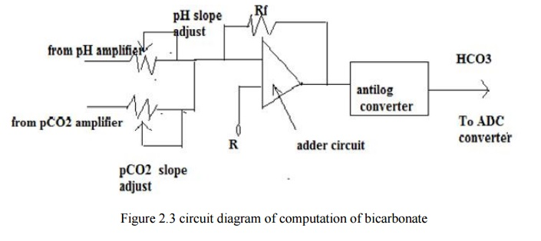

Total CO2 is calculated by summing the output signals of the (HCO3–) calculator and the output of the pCO2 amplifier. Facilities for adjusting the slope and zero at the output are available.

The base excess calculator (Fig.2.4 below ) consists of three stages. In the first stage, the output of the pH amplifier is inverted in an operational amplifier whose gain is controlled with a potentio-meter (Haemoglobin value) placed on the front panel. The output of the HCO3– calculator is inverted in the second stage. The third stage is a summing amplifier A3 whose output is given to an A–D converter.
The analog output of the selected parameter channel is given to the input of an A–D converter.
The output of the A–D converter goes to a digital readout circuit like LEDs.

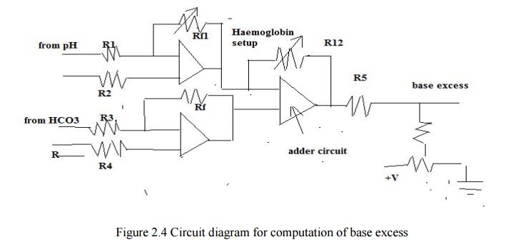

The three electrodes (pH, pO2 and pCO2) are housed in a thermostatically controlled chamber. It also provides thermostatic control for the humidification of the calibrating gases. The thermal block and the humidifier block heat control circuits are of the same type . The temperature is set with a potentiometer for exactly 37°C. The heater circuit is controlled by a thermistor in the block, which acts as a sensor. As the heat increases, the resistance of the thermistor decreases. At 37°C, the thermistor is calibrated to have a resistance of 25 K.
Supposing the temperature of the block decreases, the resistance of the thermistor will increase. The increase in resistance will cause the voltage at inverting input of op-amp to become more negative. This results in the output voltage becoming more positive, increasing the base current of transistors T1 and T2. The increase in base current increases the collector current, which goes directly to the heater resistor on the block. As the heater resistor heats up the block, the thermistor will decrease until it returns to 25 K.
Many of the blood gas analyzers have a provision for checking the membrane of pO2 and pCO2 electrodes. In the check position, a potential is applied across the membrane. Any leak in the membrane of sufficient magnitude will result in a considerable lowering of the resistance may be from 100 MW to 500 KW. The change in resistance can be used to have a change of potential to switch on a transistor, which would cause a lamp to light on the front panel of the instrument. This would indicate that a new membrane is needed.
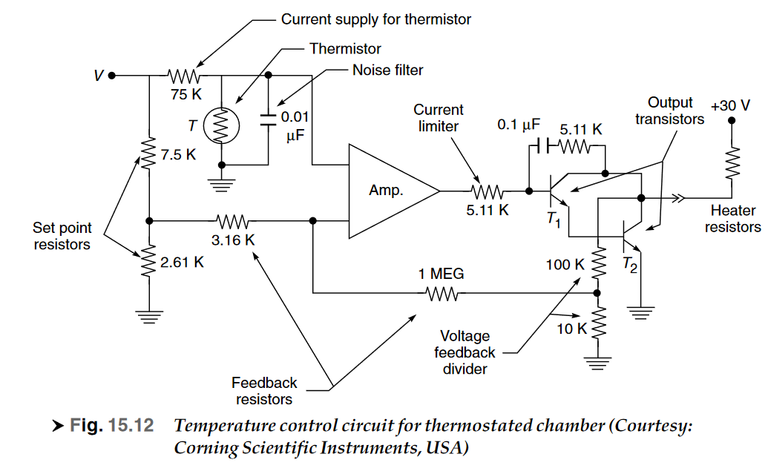
Fiber-optic Based Blood Gas Sensors

For in vivo measurements and for reliably analyzing blood gases, a small, stable, accurate and bio-compatible sensor is required which could be inserted in the blood flow of an artery (Miller, 1993) through an arterial cannula and remain in place for several days. In addition, it has to be low cost so that it could be used as a disposable item. Advances in fiber-optics and the development of pH and oxygen sensitive dyes have made such a sensor possible. Blood gas analyzers based on such sensors are now commercially available.The sensors are interfaced with an electro-optic monitor. The monitor supplies the excitation light, which may be from a monochromatic source such as a diode laser or a broadband source like a xenon lamp whose light is filtered to provide a narrow bandwidth of excitation. Two wavelengths of light are provided, one wavelength is sensitive to changes in the species to be measured, while the other wavelength is unaffected by changes in the analyte concentration. The unaffected wavelength serves as a reference and is used to compensate for fluctuations in the source output and detector efficiency. The light output from the monitor is coupled into a fiberoptic cable through appropriate lenses and optical connectors. The cable is sufficiently long to permit easy patient access by allowing the monitor to be placed at a distance.

Within the sensor assembly are three optical fibers—one each for measuring blood O2, CO2 and pH. The optical-fiber is approximately 10 cm long and also has a thermocouple or thermistor wire running along side the fiber to measure temperature near the sensor tip. Temp-erature correction is necessary for optical blood gas sensors. The solubility of the gases namely O2 and CO2 in the sensing material, is a function of temperature and the optical properties of the sensing chemistry also change as the temperature varies. The fibers and the temperature sensor are encased in a protective tubing to contain any fiber fragments in case of sensor breakage.

The sensor assembly contains three fibres that measure pH, pCO2 and pO2, bundled together with the thermocouple

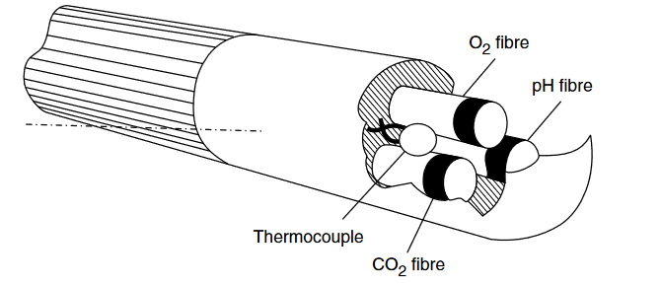

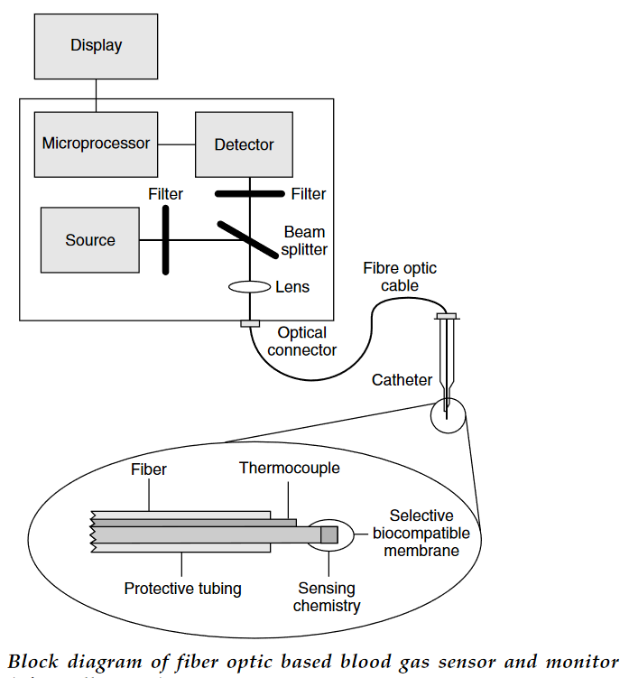

Each fiber is as thin as human hair and coated at the tip with a specific chemical dye. When light of a known wavelength strikes the dye, the dye fluoresces, giving off light of a different wavelength. The fluorescent emission changes in intensity as a function of the concentration of the analyte (O2, CO2 or pH) in the blood. The emitted light travels back down the fiber to the monitor where it is converted into an electrical signal by using a solid state detector or a photomultiplier. The signal is amplified before it is given to a digitizer. Signal processing to relate the light intensity to the analyte concentration is achieved using a microprocessor and is digitally displayed.

Because a detector produces noise or dark current when it is not illuminated, accurate signal measurements require that ambient light be subtracted from the total signal. Thus, a signal measurement is made with the flash lamp off. This ambient light is subtracted from the total signal by correlated double integration circuits. Another factor that affects accurate blood gas calculations is the background fluorescence of the materials in the optical block. This value is obtained by measuring the current developed by the detector when no sensor is connected. As with ambient light, the background fluorescence is subtracted from the signal measurement.

Within each fibre’s core, excitation light reflects along the fibre toward the fluorescent dye at the fibre's tip. The dye at the tip reacts to the excitation light and analyte concentration by fluorescing. The fluorescent signal then returns in the same fibre to the monitor, which measures the intensity of the signal

Considerable effort has gone into identifying organic molecules, which would make suitable sensors. These molecules must have a high fluorescent intensity at excitation and emission wavelengths that match the available light sources and detectors. They must be photostable, i.e. their emission properties should not change as they are continually illuminated by the excitation source. Sensors based on fluorescence quenching of organic dyes such as perylene dibutyrate have been reported for the measurement of pO2. Oxygen sensors based on the phosphorescence quenching of metal—loporphyrins and terbium complexes have also been successfully tried.

It has been found from experimental studies that as the partial pressure of oxygen increases, the sensitivity decreases. The best sensitivity is achieved in the region of 30 to 150 mmHg, but drops off considerably with higher pO2, making it difficult to resolve small changes in pO2, when the oxygen partial pressure is greater than 200 mmHg. Further, at high pO2 as the quenching increases, the light reaching the detector decreases. A compromise is thus required to be made in selecting a sensing material that provides adequate sensitivity over the required pO2 measurement range and simultaneously offers good signal-to-noise ratio at the detector. The performance range of the sensor is normally limited to under 300 mmHg in order to achieve good sensitivity and adequate light detection.

pH sensor:
Designs are based on dye molecules whose optical properties change as the pH is varied between 6.8 and 7.8. At any pH in the range of interest, both the acid and base forms of the dye molecule are present and each form has distinct optical characteristics. pH sensors have been developed which take advantage of the fact that the excitation wavelength for fluorescence emission of some dyes is different for the acid and base forms and the ratio of emission excited at these two wavelengths can be used to calculate pH. Additionally, sensors have been developed which utilize the difference in absorption maxima for both the acid and base forms of the dye.

The commonly used pH-sensitive dye is phenol red whose absorption spectra. The largest peak is observed from base form of phenol red at 560 nm and is used to measure pH because it is more sensitive to pH changes than the acid peak at 430 nm. A wavelength, which is insensitive to pH changes, is used as a reference; either a wavelength greater than 600 nm or the isobestic point at 480 nm.
One of the difficulties in designing a pH sensor is to achieve resolution of 0.01 pH units over the range of 6.8 to 7.8. An effective way to achieve this is to optimize the pKa of the dye material. This can be done through proper choice of a functional group attached to the dye molecule or by immobilizing the pH-sensitive material on a polymer with the appropriate ionic characteristics.

Most fiberoptic sensors for measuring pCO2 use the same approach as a pCO2 electrode. A pCO2 sensor is fabricated by surrounding a pH sensor with a gas permeable membrane containing a bicarbonate ion (HCO–3 ) buffer. The membrane allows gaseous CO2 and water vapour to enter the sensor, and they combine to form carbonic acid

This principle for the design of pCO2 sensors has been implemented using both fluorescence-based and absorption-based pH sensors (Vurek et al., 1983).
The methods for measuring pH, CO2 and O2 are similar, except that the wavelength of light used for different blood gas parameters vary. The optics is composed of three channels, each for measuring one of the parameters. Provision for calibration is made in the measuring system to compensate for individual physical variations between sensors and monitors. The calibration technique involves placing the sensor in a calibration solution, then bubbling precision mixtures of O2, CO2 and nitrogen (N2) through the fluid. When equilibrium is reached, there are known partial pressure of O2 and CO2 in the solution. The pH is also known from the gas tensions and the chemical composition of the solution. Bubbling is repeated with a second gas mixture to provide a second calibration point. Using both calibration points, the monitor can calculate the appro-priate calibration factors for that sensor.

With the development of fiber-optic based blood gas sensors, routine electrode membraning and maintenance have become history. Continuous self-monitoring provides clear and immediate information of instrument performance. The keyboard-based user interface provides advanced analytical performance and data processing capabilities. Along with measurement of the blood pH, pO2 and pCO2, some instruments like the AVL OPTI Critical Care Analyzer (Fig. 15.17) also include facilities for measuring other important ions such as Na+, Ka+, Ca++ and Cl– in the blood. This is possible with the development of optical sensors based on fluorescence emission. All the sensors are mounted on a cassette shown in Fig. 15.18. The syringe adapter shown at the right side of the cassette allows the automatic aspiration of a sample directly from a syringe. Removing the adapter allows for direct sample aspiration from a capillary or microsampler. The sensor calibration is verified by the system automatically after insertion of the cassette. The cassette is removed after sample analysis.
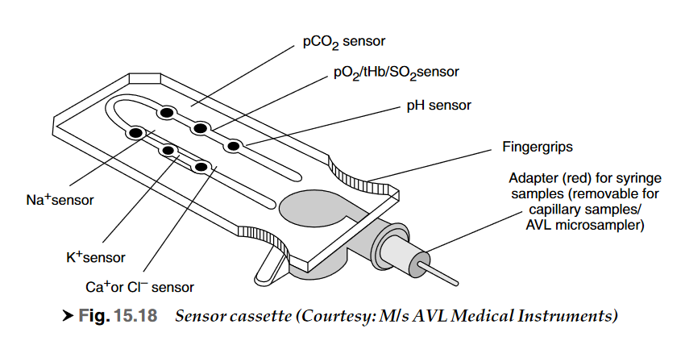
The optical sensors in the cassette are designed in a way that the analytes bind with the fluorescent sensor molecule. The sensor molecule is selective for the specific analyte, i.e. the pH sensor molecule reacts only with “H+”, the O2 sensor only with O2 molecules, etc. The intensity of the emitted fluorescent light varies with the concentration of the ions (H+, Na +, K+) or the partial pressure of the gas molecules (O2 and CO2) in the sample. The relationship is specific for each analyte. The corresponding calibration information for each component is encrypted in the bar code. Before the analyte can bind to the fluorescent molecule, it is made to pass through an optical isolator. The isolator prevents interference by unspecific light with the light detection system. The pO2 sensor also makes it possible to measure and compute the total haemoglobin and oxygen saturation. The equipment works on a minimum sample size of 125 ml.
With the miniaturization of the direct reading electrodes, it is possible to combine them into a single cuvette so that a complete blood gas determination could be made on a single small sample.
The introduction of the microprocessor and its use in blood gas analyzers free the medical personnel from monitoring the reaction in the electrode chamber and from the tedious chores of calculating and copying the results.
All commercial blood gas analyzers make use of the same basic electrodes and signal conditioner circuitry. The main differences between instruments manufactured by various companies are not the measurements of the parameters but the degree of automation and the technique by which the sample is presented to the electrodes.

